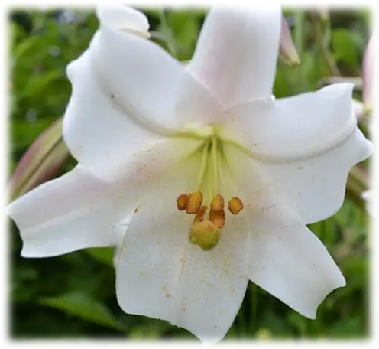
Little Falls Presbyterian Church Sanctuary Flowers Order Form
-------------------------------------------------------------------------------------------------

The sanctuary will be adorned with Easter lilies and tulips.

Please complete this form and place it in the basket at the sanctuary entrance, mail to LFPC
or drop it by the church office with a check labeled “Easter Flowers” in the memo line.

The cost of one flower is $20.

Number of flowers you wish to sponsor: _______ x $20 = $________

□ Given by:_______________________________________________
□ Wish to remain anonymous

Please select the following:
Flower #1:
□ In Honor of: _____________________________________________
□ In Remembrance of:_______________________________________
□ To the Glory of God

Flower #2:
□ In Honor of: _____________________________________________
□ In Remembrance of:_______________________________________
□ To the Glory of God

Flower #3:
□ In Honor of: _____________________________________________
□ In Remembrance of:_______________________________________
□ To the Glory of God

For more than 3 flowers, please use the
back side and check this box: □

